**SETTING UP THE CAMERAS AND SOUND SYSTEM**

1. Turn on the power strip at the back of the church
2. Turn on BOTH cameras
   1. White dots indicate that the cameras are on and the battery life level.
   2. Green light in front indicates you are connected to the network:

(st aidans video, Password = video2020)

* 1. Altar Camera should be placed in front of the font and extended to its full height.
  2. Lectern camera should be in front of the Lectern.

1. Make sure the black cable is plugged into the LECTERN Camera
2. Turn on YAMAHA mixer on back table. Make sure RED and YELLOW knobs are turned up in the position as shown.

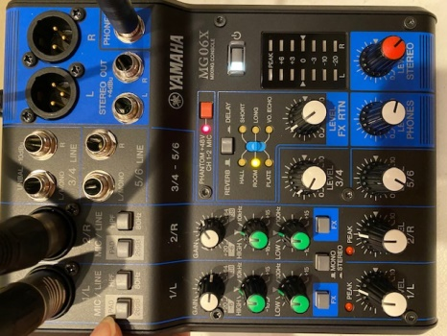 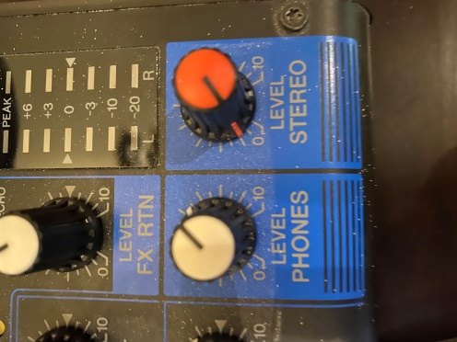

ON button Volume buttons

**SETUP FOR FACEBOOK LIVE**

1. Bring up the MEVO MULTICAM application on the Camera Controller. (Passcode = 2020 OK)
2. Once loaded, it will display the two cameras.

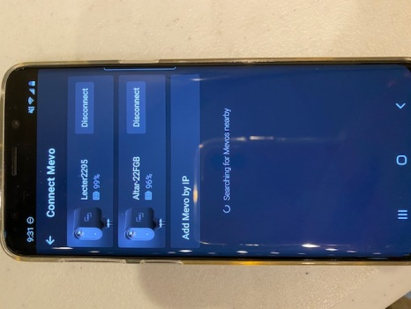

1. Connect to Both
   1. NOTE: There will be a spinning icon indicating “Searching for Mevo’s nearby”. *** This is OK as long as long as the two cameras displayed are connected.
2. Press the 🡨 (back arrow) at the top of the screen OR CONTINUE at the bottom
3. Now you will see three pictures on the screen:

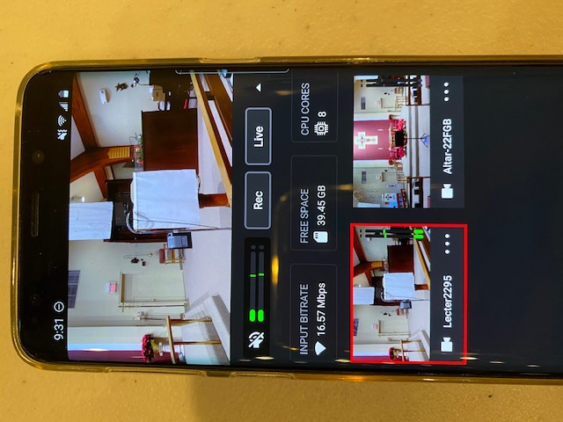

* 1. Top screen is what is active
  2. Lectern Camera view
  3. Altar Camera view

**NOTE : Depending on how the cameras connected the bottom two views may be reversed.**

* 1. Press the 3 dots in the lower right hand corner of the Altar camera. Select CROP AND ZOOM. Zoom in on the altar as needed during the service. **During communion, zoom into the cross above the altar so no people are in the frame.**
  2. Press the 3 dots in the lower right hand corner of the Lectern camera. Select CROP AND ZOOM. Zoom in on the speaker as needed.

1. Select the icon at the bottom of the screen - This displays the audio for the cameras.

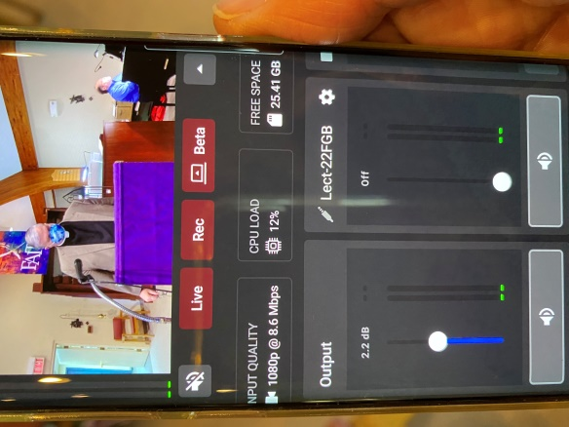 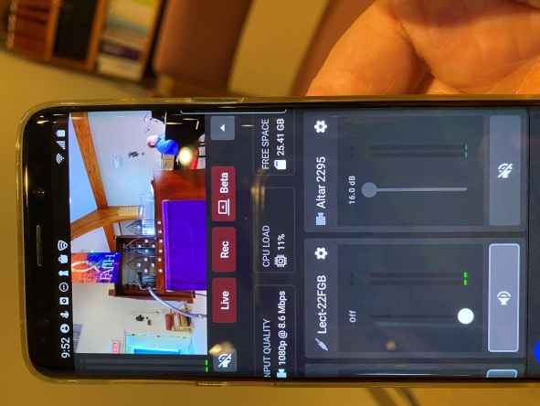

Phone / Output / Lect Lect / Altar

**NOTE: Depending on how the cameras connected, the Lect and Altar views may be switched. BUT THE OUTPUT will always be on the left with either the LECT or the ALTAR to the right of it. To see the third camera, swipe right. To return to the OUTPUT, swipe left.**

**MAKE SURE YOU SELECT THE CORRECT MICROPHONE SETTINGS**

* 1. Altar Camera = **muted**
  2. Phone speaker (speaker to the left of the LIVE button) = **muted** (but green bar will still increase and decrease)
  3. Lectern Camera = **ON** - **MOVE SLIDE BAR HALF WAY UP. This allows the output to work. However, the green bar will not change on this screen.**
  4. Output = **ON** (green bar will increase and decrease)

You should see the **green bars** go up and down for the **OUTPUT** and the **PHONE** speaker (even though it is muted).

1. **Adjust the slide bar on the OUTPUT to adjust the volume.**
2. Press  icon to return to the main menu.
3. When ready to go LIVE:

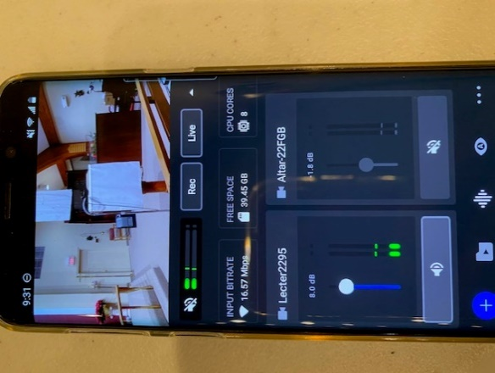 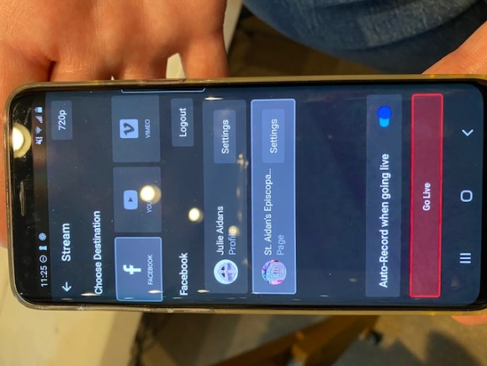

* 1. Press the LIVE key
  2. Select FACEBOOK
  3. Select St. Aidan’s Episcopal Church
  4. Press the GO LIVE button at the bottom

1. To stop the LIVE feed, press the LIVE key again.

The message “Stop Streaming, Are you sure you would like to stop the streaming?” **PRESS STOP**

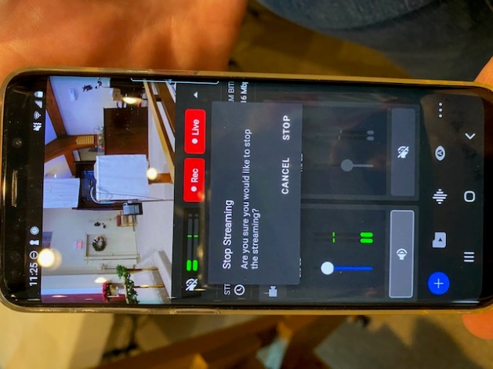

**NOTE*: IF*** the *REC button is RED, Press the *REC button and the message “Stop Recording, Are you sure you would like to stop the recording? **PRESS STOP**

1. To disconnect the cameras:

Select each camera to disconnect.

You’ll receive the message “Do you really want to disconnect from camera?” **PRESS YES**

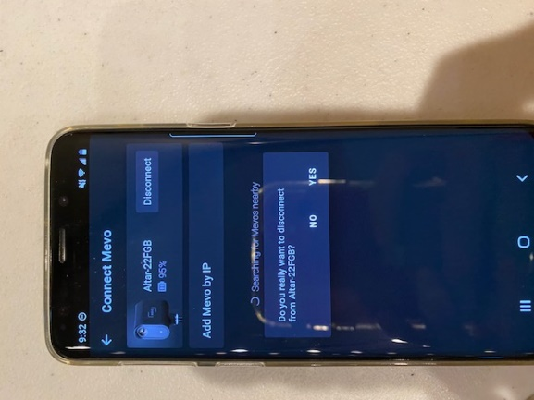

1. If you return to the main Samsung screen, and you haven’t disconnected from the cameras, you will get the message:

“Mevo MultiCam is running. Tap to return to Mevo Multicam or Turn off.” Press **TURN OFF.**

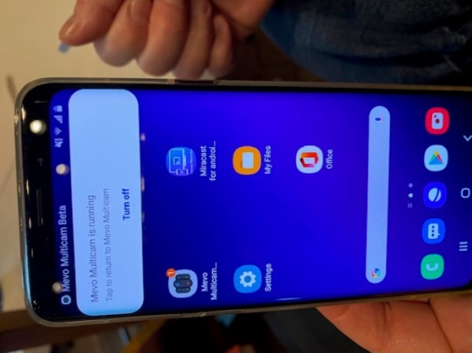

1. Turn off both cameras, power strip in the back, Yamaha mixer, and camera controller. Plug in cameras and camera controller to chargers in the office. Yamaha mixer can stay on the table.