**SETTING UP THE CAMERAS AND SOUND SYSTEM**

1. Turn on power strip in the back corner of the Nave.
2. Turn on the mixing board on the small table on the back, right side of Nave.

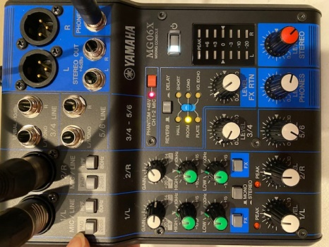

1. Turn on BOTH cameras – button on back
   1. White dots indicate that the cameras are on and the battery life level.
   2. Green light in front indicates you are connected to the network:

(Network = st aidans video, Password = video2020)

* 1. Altar Camera should be placed in front of the font on tripod.
  2. Lectern camera should be on the handrail mount.

1. Make sure the black cable is plugged into the LECTERN Camera.
2. Check with Fr. Tom to make sure he has his wireless microphone on.
   1. IF THERE IS A DEACON, or other priest who will be speaking, make sure they have the second wireless microphone on. It is in the sacristy on the file cabinet.

**SETUP FOR FACEBOOK LIVE**

1. Bring up the MEVO MULTICAM application on the Camera Controller. (Passcode = 2020 OK)
2. Once loaded, it will display the two cameras.

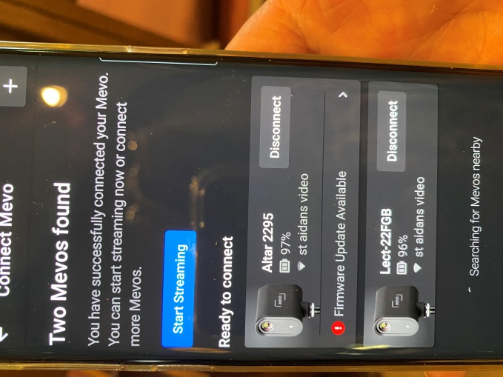

1. Connect to Both
   1. NOTE: There will be a spinning icon indicating “Searching for Mevo’s nearby”. *** This is OK as long as long as the two cameras displayed are connected.
   2. NOTE: Do not start streaming from this screen.
2. Press the 🡨 (back arrow) at the top of the screen
3. Next you will see three pictures on the screen:

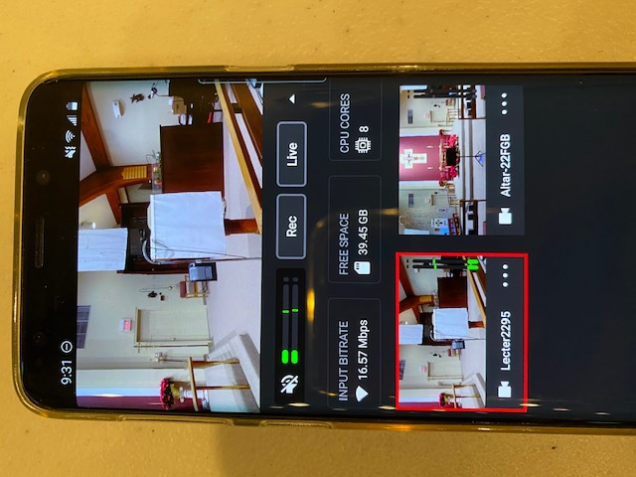

* 1. Top screen is what is active
  2. Lectern Camera view
  3. Altar Camera view

**NOTE :** Depending on how the cameras connected, the bottom two views may be reversed from the picture above**.**

1. Make sure the Audio is setup:

Select the icon at the bottom of the screen - This displays the audio for the cameras.

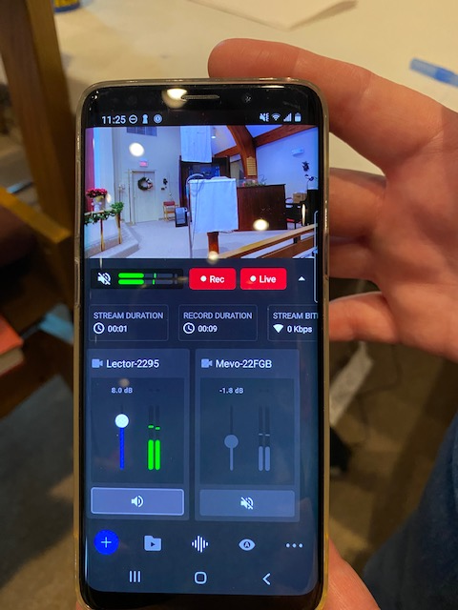.

**NOTE :** Depending on how the cameras connected, the bottom two views may be reversed from the picture above**. MAKE SURE YOU SELECT THE CORRECT ONE:**

1. Altar Camera = **muted**
2. Phone speaker (speaker to the left of the *REC button) = **muted**
3. Lectern Camera = **ON**

**NOTE:** You should see the **green bars** go up and down for the Lectern Camera and the Phone speaker (even though it is muted)

**When these two are green = sound is on correctly.**

1. Slide the bar on the LECTERN CAMERA to a quarter of the way up.
2. Press  icon to return to the main menu
3. When ready to go LIVE:

Have Mark start playing one introductory song about 3 minutes before service starts.

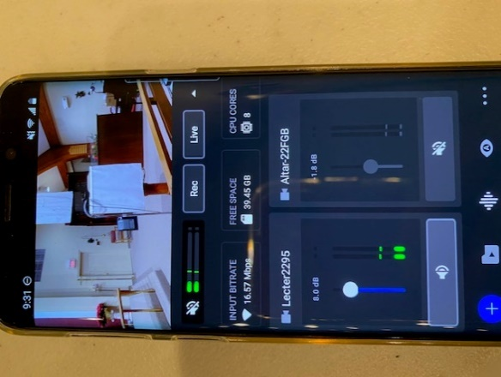 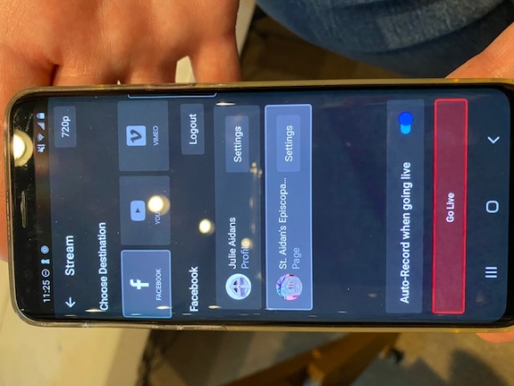

* 1. Press the LIVE key
  2. Select FACEBOOK
  3. Select St. Aidan’s Episcopal Church
  4. Press the GO LIVE button at the bottom

**NOTE:** If St. Aidan’s is not displayed and you need to login, use:

ID = staidansolathe@sbcglobal.net PSWD = Aidans2020

Sign in as JULIE AIDANS

1. To stop the LIVE feed, press the LIVE key again.

The message “Stop Streaming, Are you sure you would like to stop the streaming?” **PRESS STOP**

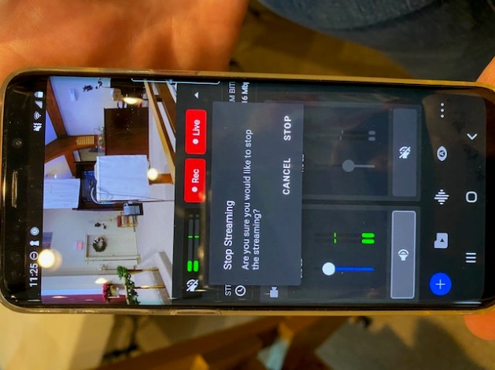

**NOTE*: IF*** the *REC button is RED, Press the *REC button and the message “Stop Recording, Are you sure you would like to stop the recording?” **PRESS STOP**

1. To disconnect the cameras, press the ‘+’ key on the bottom left.

Select each camera to disconnect.

You’ll receive the message “Do you really want to disconnect from camera?” **PRESS YES**

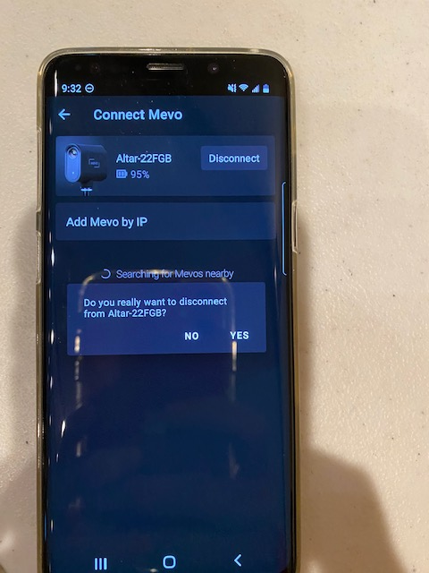

1. If you return to the main Samsung screen, and you haven’t disconnected from the cameras, you will get the message:

“Mevo MultiCam is running. Tap to return to Mevo Multicam or Turn off.” Press **TURN OFF.**

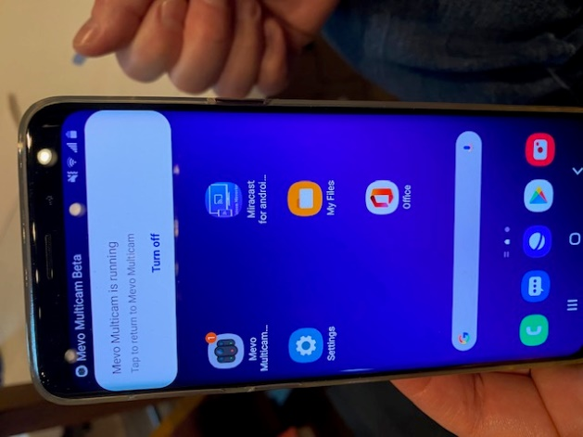

1. Power all devices down.
   * 1. Camera on tripod can remain on tripod and taken to office.
     2. Camera on handrail disconnects by pressing down button

behind it and sliding the camera backwards. (Inserts over button and slides forward.)

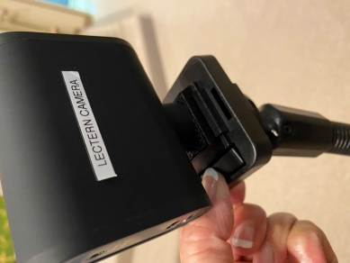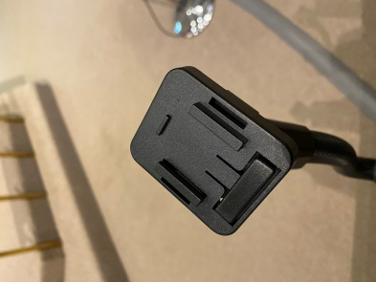

* + 1. Power strip in the back
    2. Yamaha mixer
    3. Camera controller

Plug in cameras and camera controller to chargers in the office. Yamaha mixer remains on the table.

**OPERATING PROCEDURES DURING THE SERVICE**

**You will need to zoom in both cameras for the service. The procedures are the same, just different views.**

1. ZOOM in the view on the cameras by doing the following steps.
2. Select the 3 dots in the lower right hand corner of the camera picture.

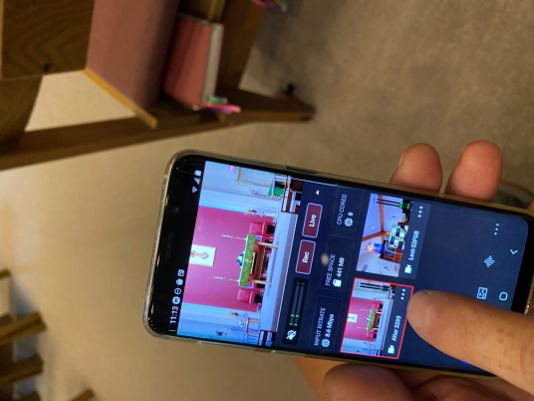

1. Select “Crop and Zoom”.

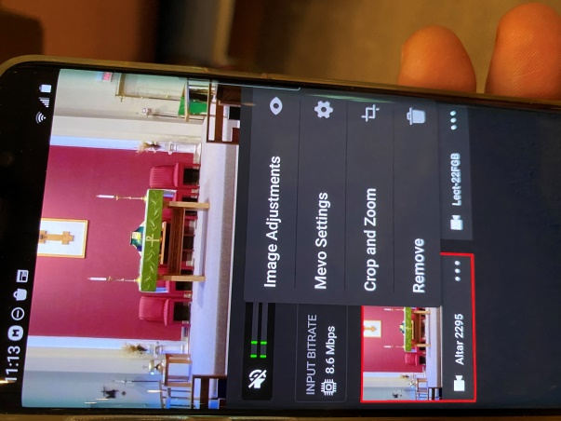

1. The image will be displayed in landscape form.

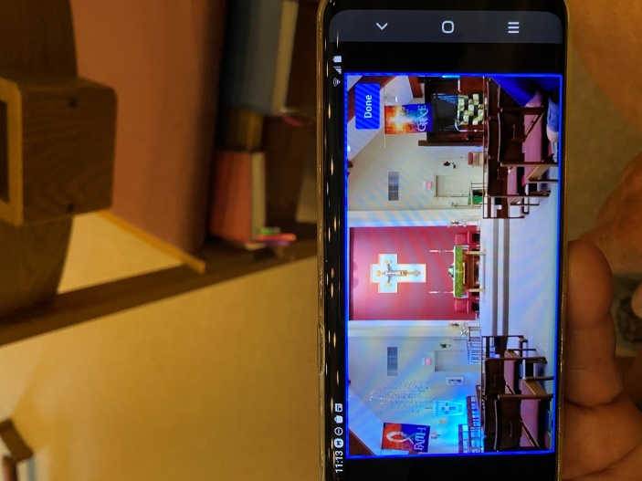

1. Select where you want the focus to be by touching the screen and making the rectangle larger or smaller.

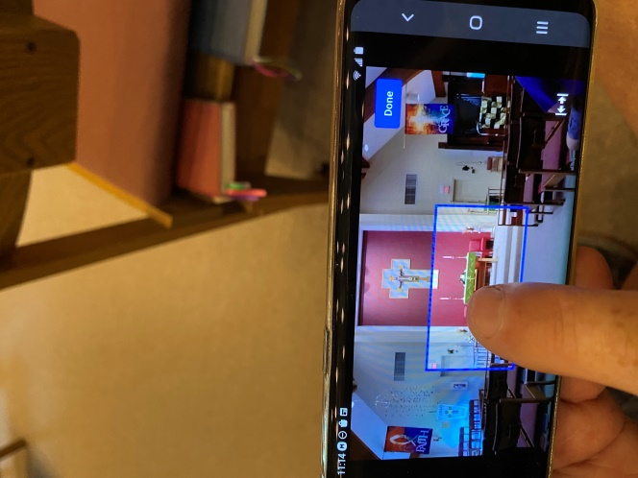

1. Press DONE when finished.

**NOTE**: The LIVE broadcast will not be changed until you press DONE.

**FOR THE ALTAR CAMERA**

* Place the tripod in front of the font. The legs should be the same width so it will not have to be moved for the service.
* Zoom into the altar.

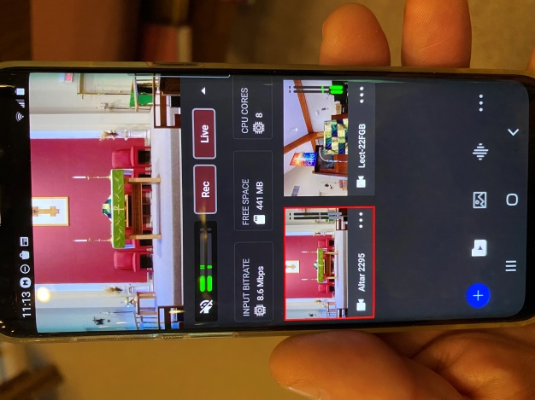

**FOR THE LECTERN CAMERA**

* During the readings, you may choose to zoom in on the reader, but you do not need to.
* During the communion, Zoom in on the Grace flag

